**API Testing Assignment**

URL - <https://dummy.restapiexample.com/api/v1/employees>

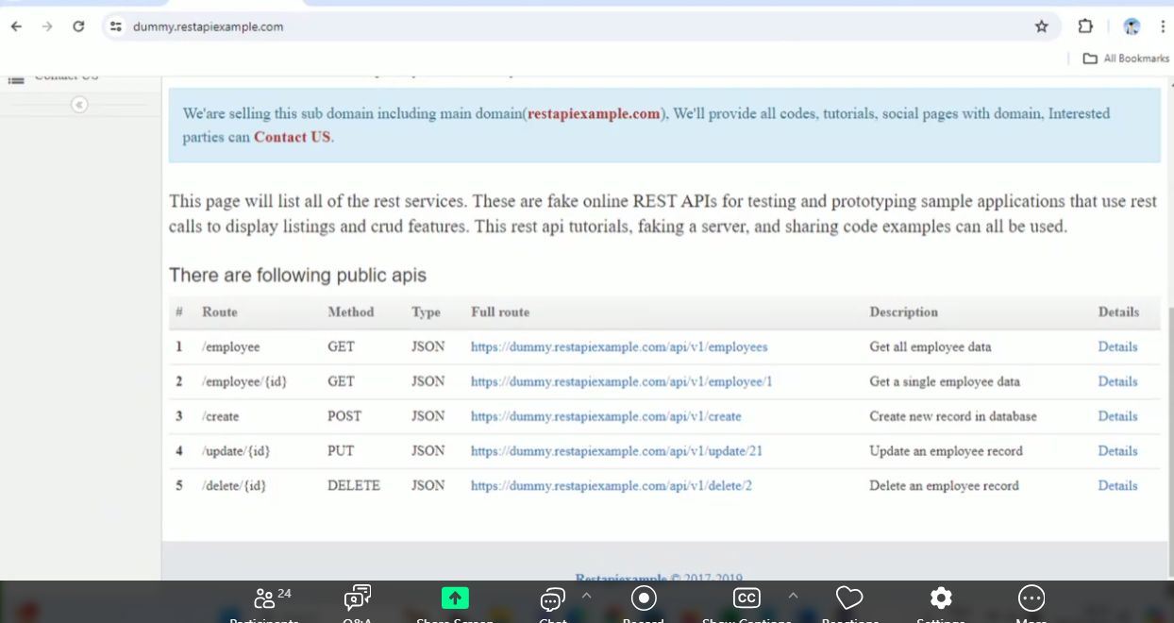

**Collection Name: Nagalakshmi_DummyRestAPI**

**GetEmployees**: <https://dummy.restapiexample.com/api/v1/employees>

**GET Method:**

Updated the script by adding validation points like response code, salary and age as non-negative integers, content type as json, response time and validation for the employee_name contains Kennedy with the help of BOT in the below 3 screenshots.

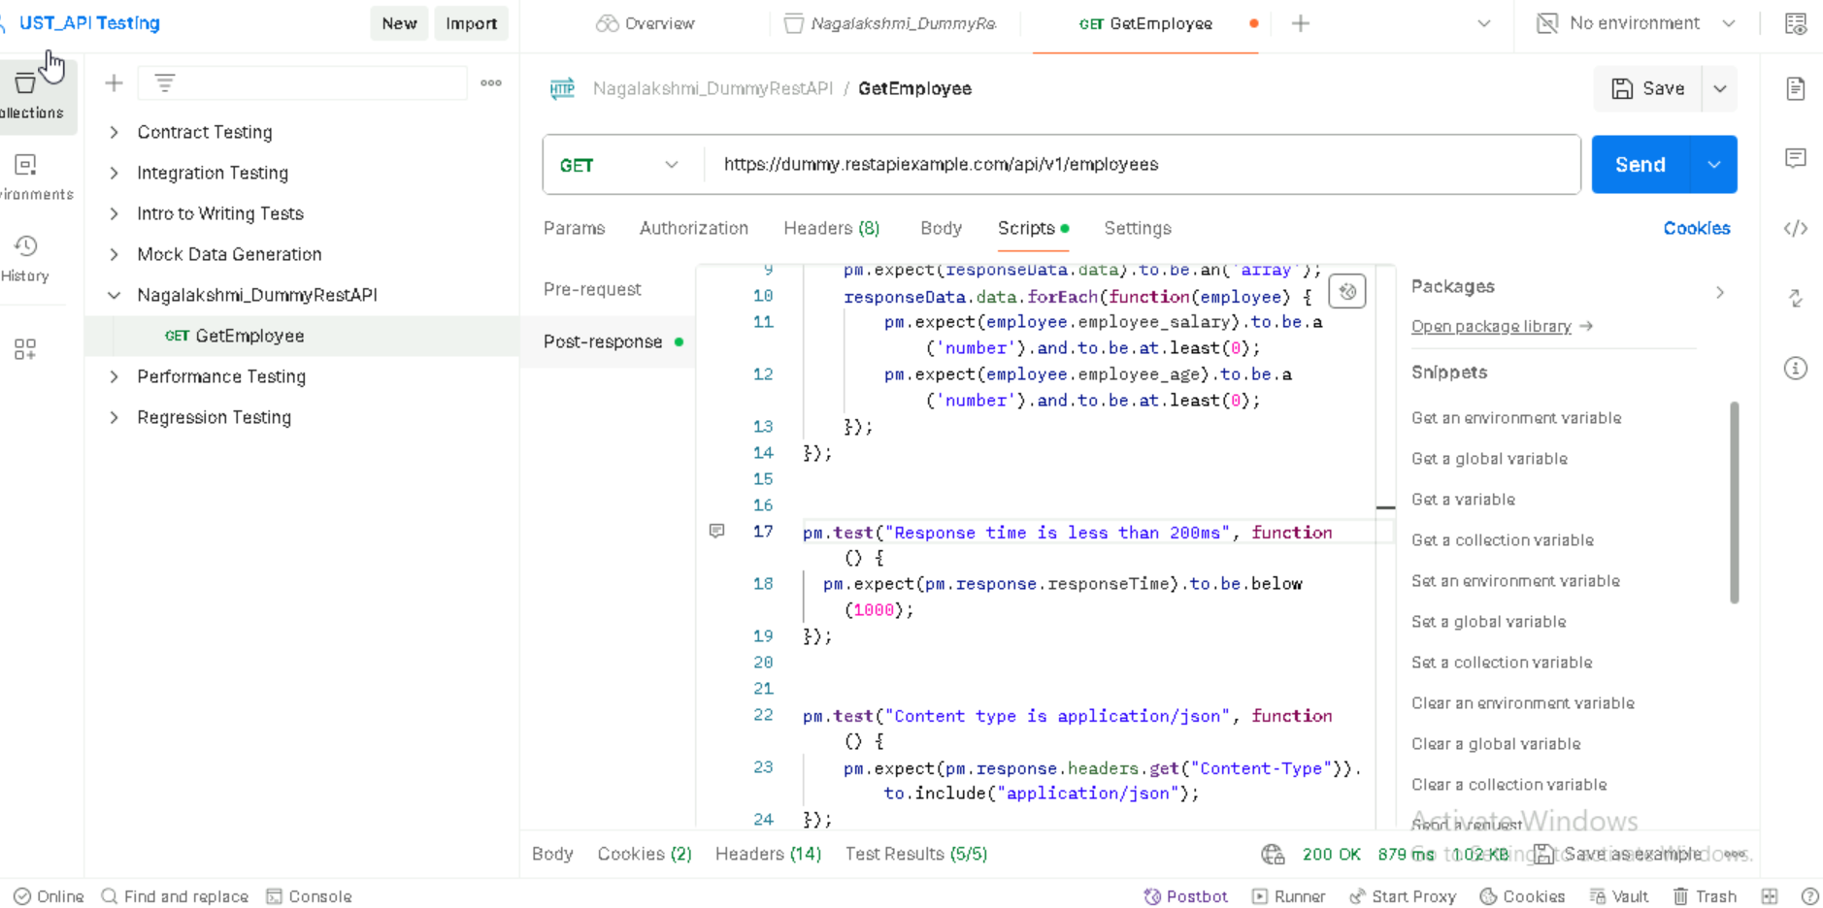

**Response code – 200 Ok** with the Test Results.

**Response code – 200 Ok** with the Body

**Response code – 200 Ok** with Visualize in the Body

**CreateEmployee:** <https://dummy.restapiexample.com/api/v1/create>

**POST method:**

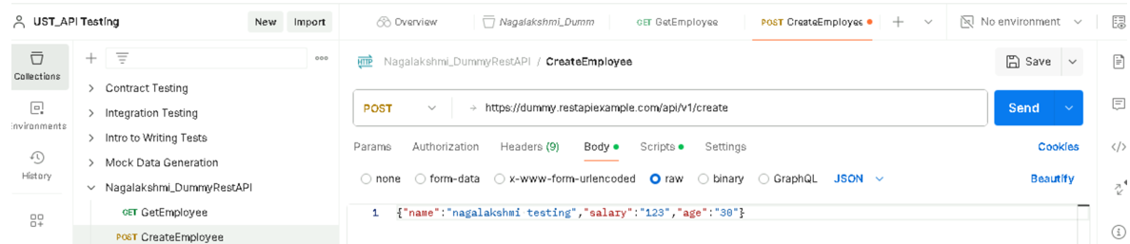

**Response code – 200 Ok** with the Body.

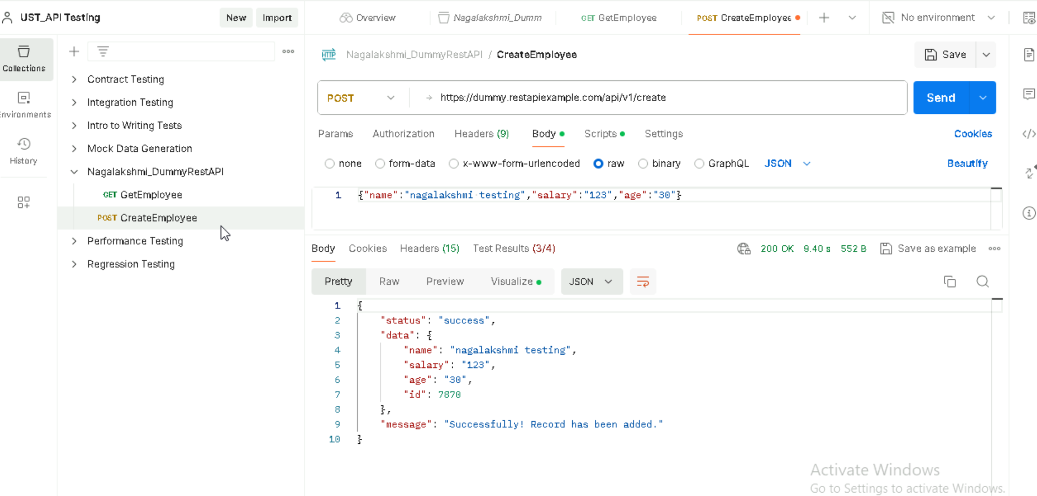

**Response code – 200 Ok** with the Test Results for validation points.

Response in Visualize format:

**UpdateEmployee:** [https://dummy.restapiexample.com/api/v1/update/21](https://dummy.restapiexample.com/api/v1/update/21/)

**PUT method:**

Update employee details like salary and age.

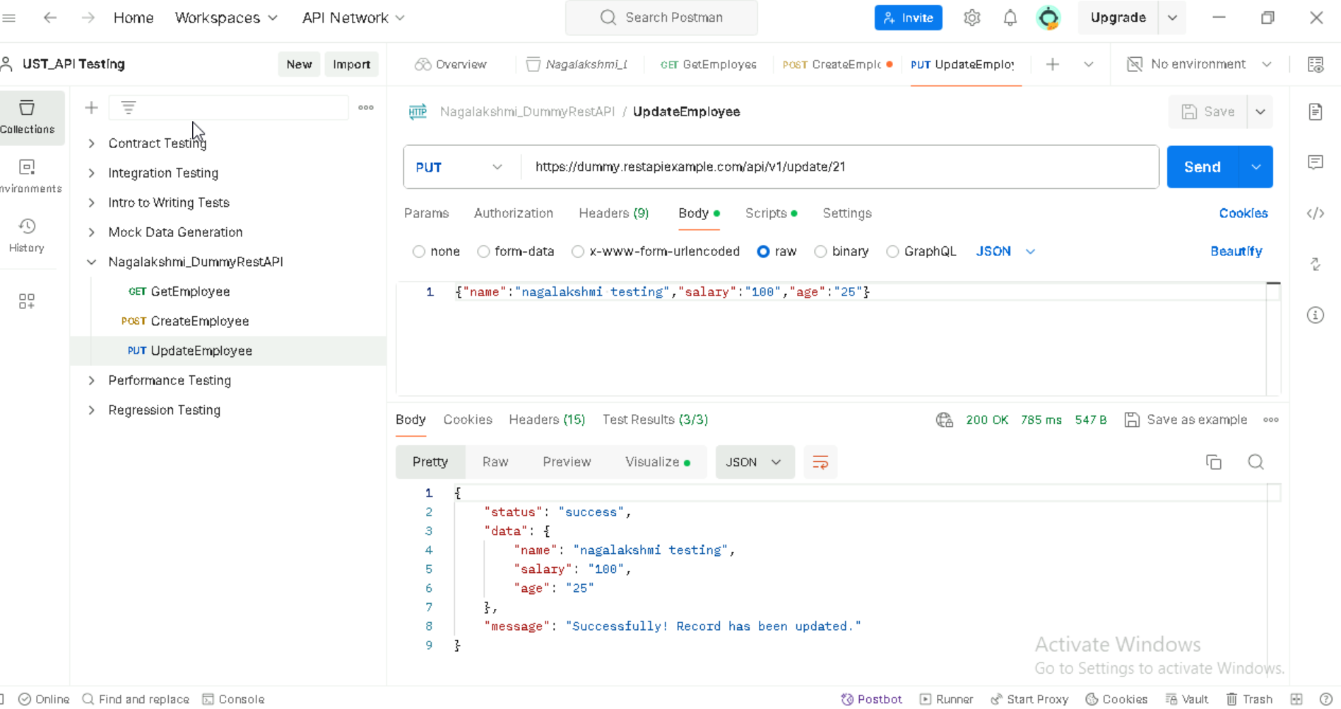

**Response code – 200 Ok** with the Test results for the validation points in the script.

Updated results in Visualize format.

